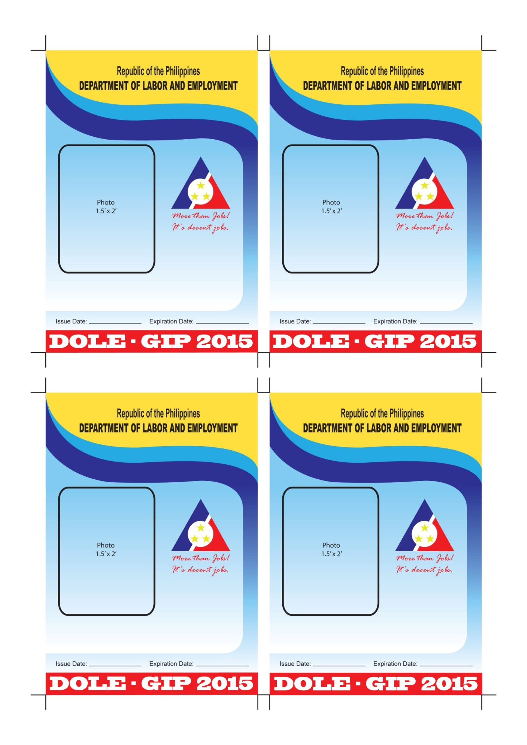

**REGION XII**

**REGION XII**

**REGION XII**

**REGION XII**

**ID No. 15XIINC00001**

**ID No. 15XIINC00002**

**LAWRENZ JANEUS LICATAN BANCO**

**NAME &SIGNATURE**

**JASON J. ARISTON**

**NAME &SIGNATURE**

11/18/2015

11/18/2015

5/18/2015

5/18/2015

**ID No. 15XIINC00003**

**ID No. 15XIINC00004**

**LEONISA T. CADORNIGARA**

**NAME &SIGNATURE**

**KRIZZA POMILLE B. BANTING**

**NAME &SIGNATURE**

5/18/2015

11/18/2015

11/18/2015

5/18/2015

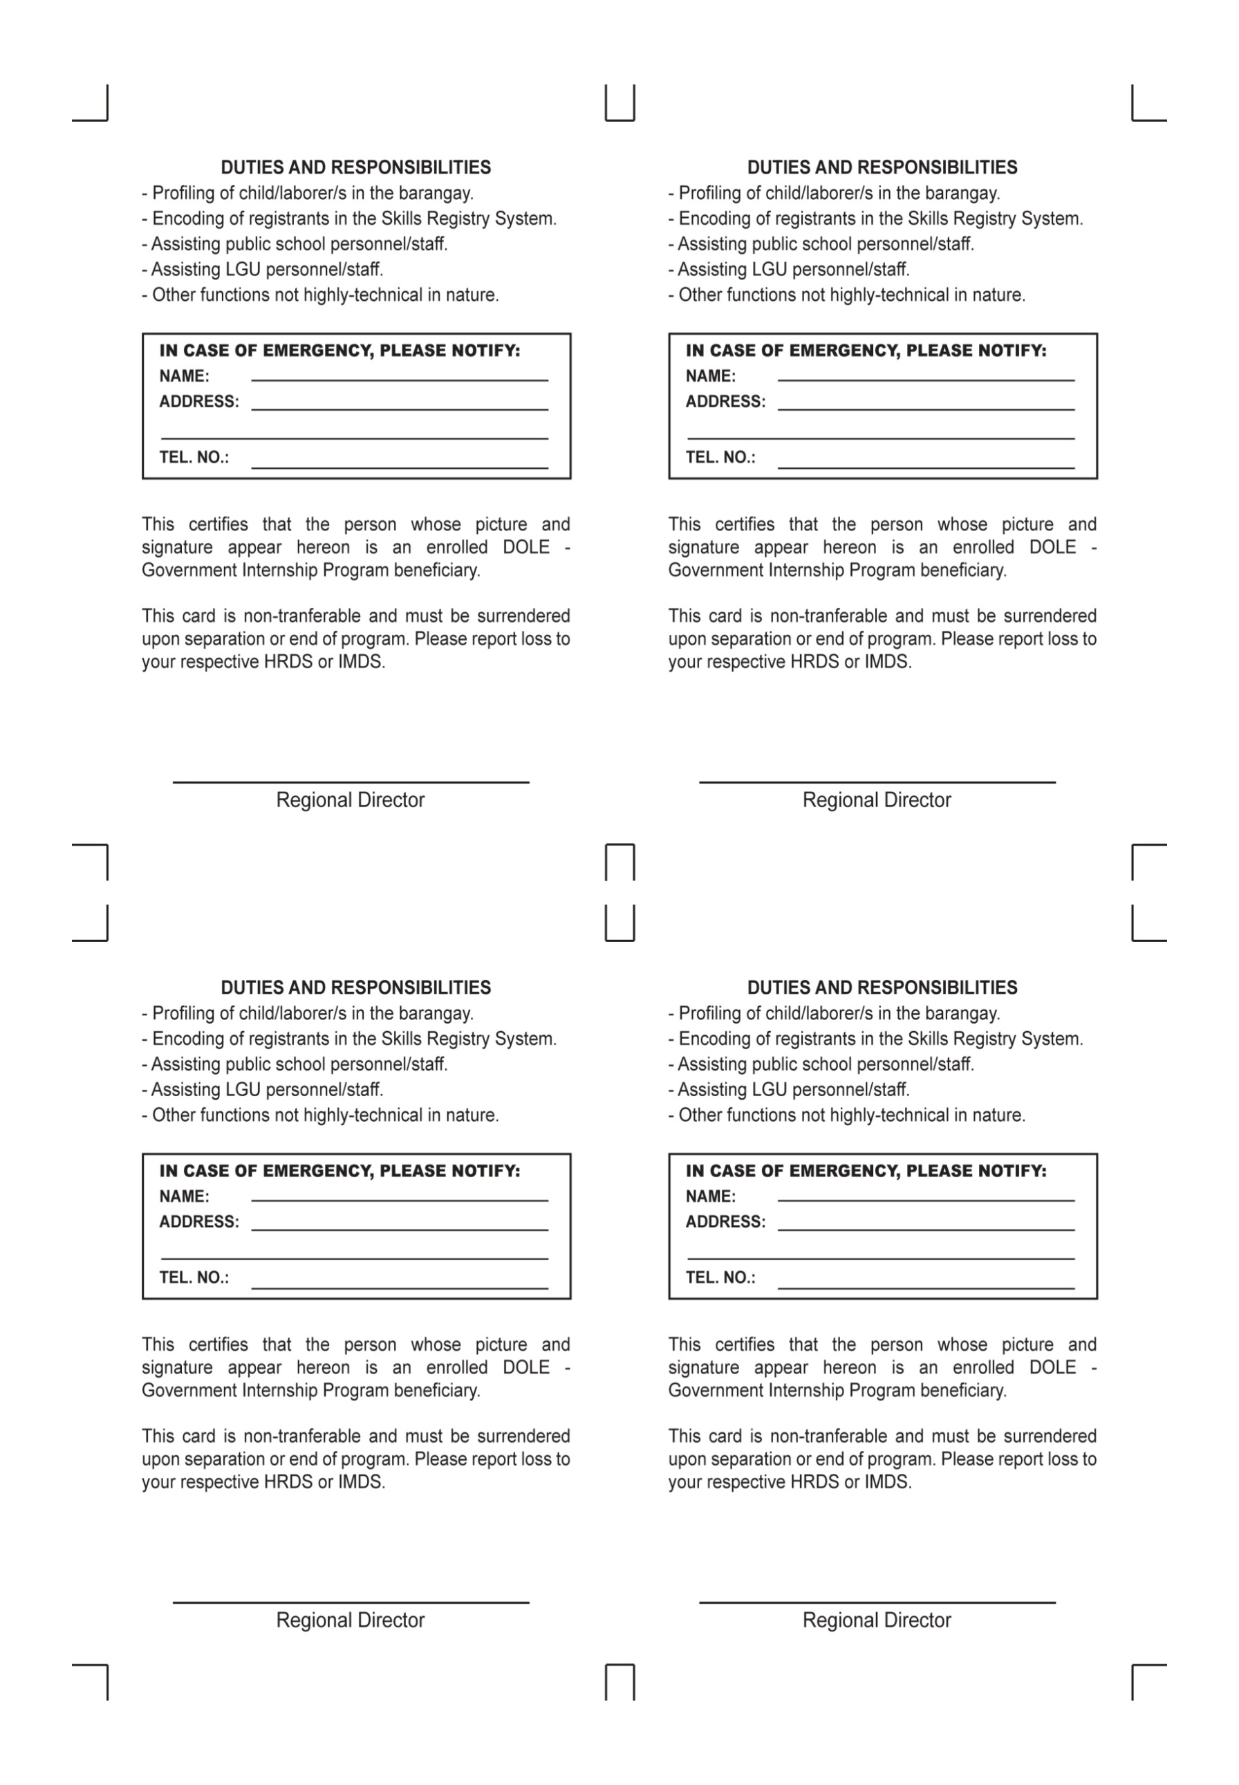

**BLK. 6 LOT.3, VALLE SUBD.**

**IRINEO ABES BANCO JR.**

**09186490987 / 09293222084**

**LANAO, KIDAPAWAN CITY**

**MARJORIE P. LATOJA**

**MARJORIE P. LATOJA**

Chief LEO/NCFO Head

Chief LEO/NCFO Head

**MARJORIE P. LATOJA**

**MARJORIE P. LATOJA**

Chief LEO/NCFO Head

Chief LEO/NCFO Head



**REGION XII**

**REGION XII**

**REGION XII**

**REGION XII**

**ID No. 15XIINC00006**

**ID No. 15XIINC00005**

**ROMEO V. CANGAYDA JR.**

**NAME &SIGNATURE**

**APRIL JOY CAMANZO**

**NAME &SIGNATURE**

11/18/2015

11/18/2015

5/18/2015

5/18/2015

**ID No. 15XIINC00007**

**ID No. 15XIINC00008**

**LORENAL. DAGUING**

**NAME &SIGNATURE**

**JENNELYN P. CORTEZ**

**NAME &SIGNATURE**

5/18/2015

11/18/2015

11/18/2015

5/18/2015

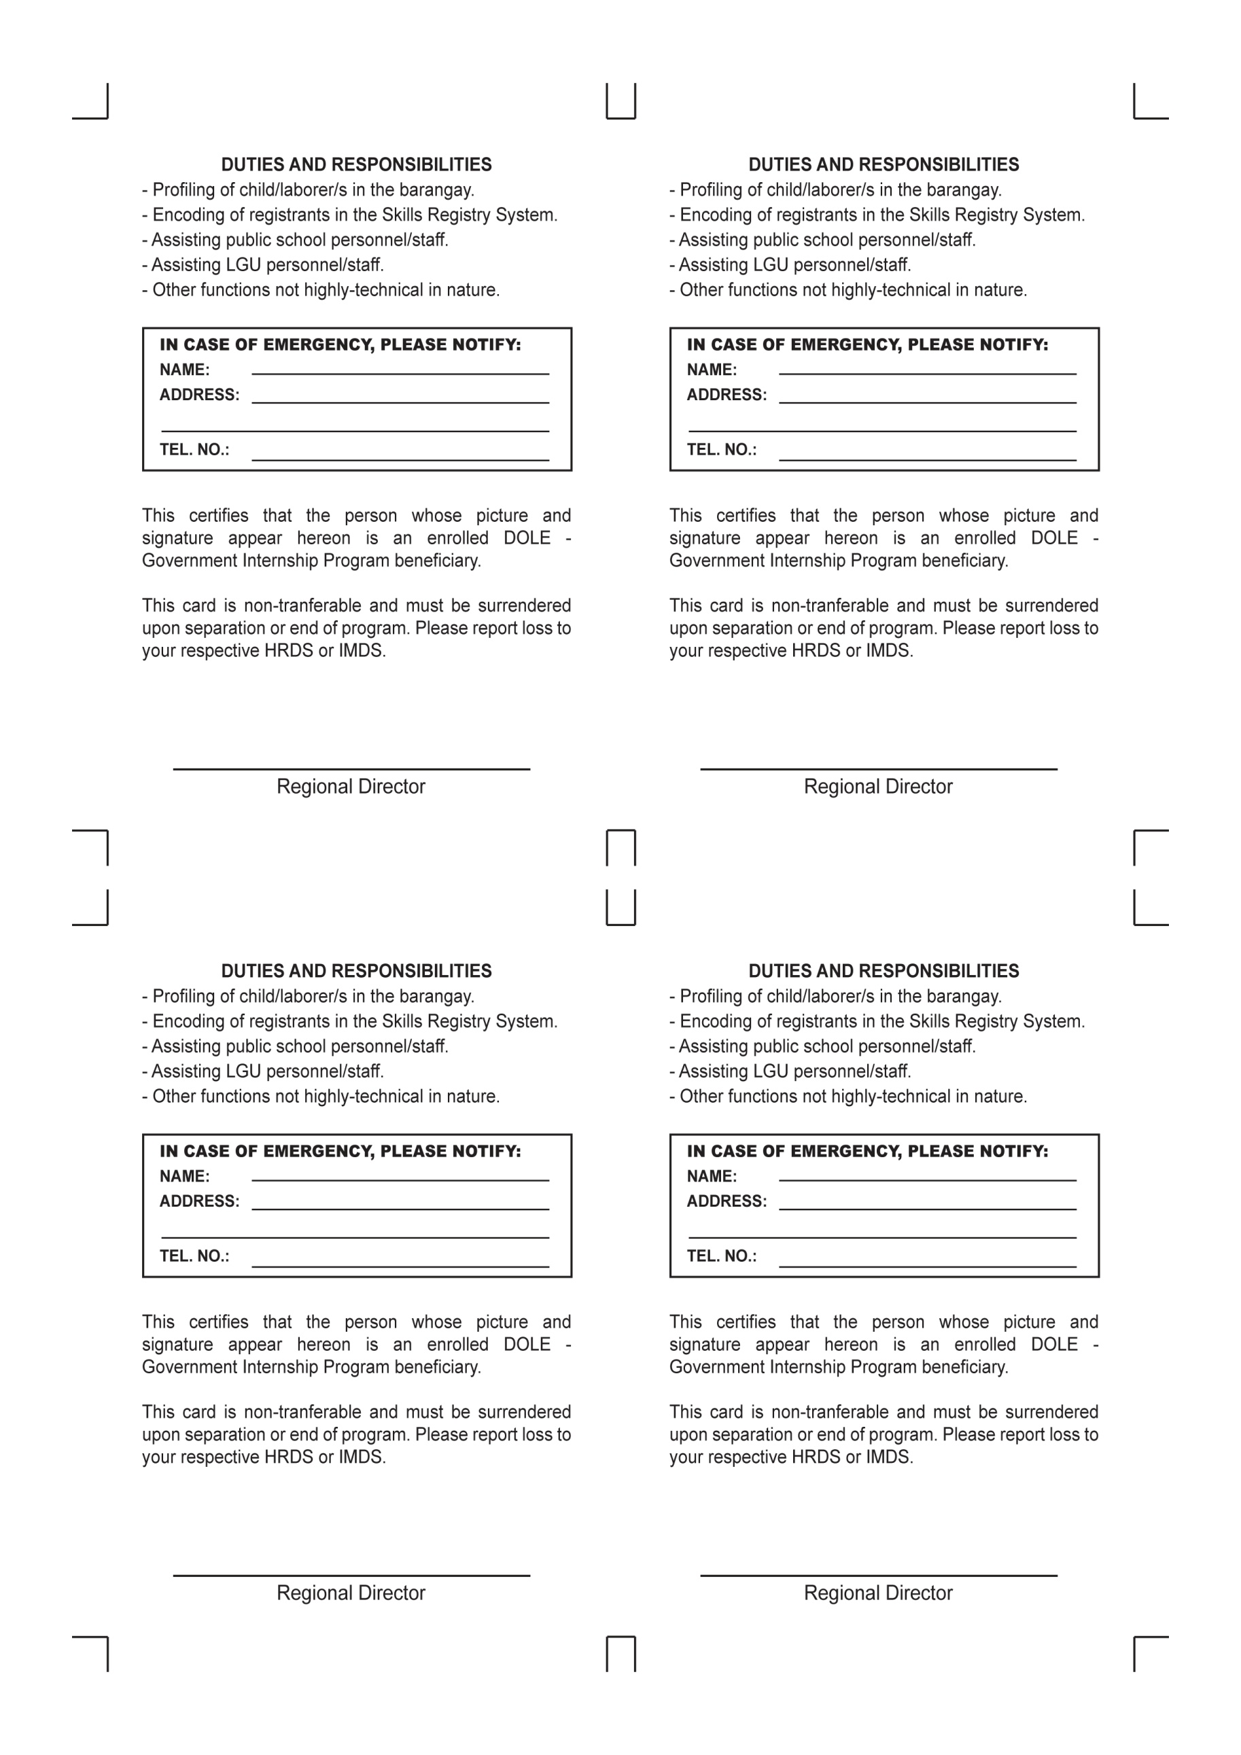

**MARJORIE P. LATOJA**

**MARJORIE P. LATOJA**

Chief LEO/NCFO Head

Chief LEO/NCFO Head

**MARJORIE P. LATOJA**

**MARJORIE P. LATOJA**

Chief LEO/NCFO Head

Chief LEO/NCFO Head